Introductory report

We decided on the alarm clock which drives away when the alarm is activated. To shut it off we have thought about using the accelerometer, so when you shake it the alarm would go out.

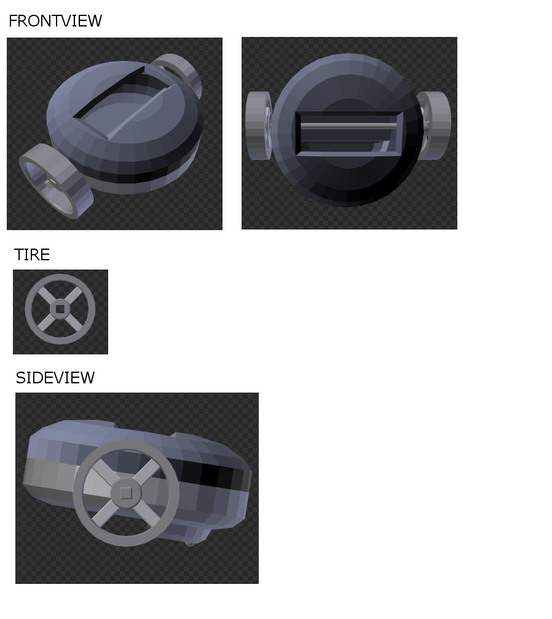The decision to go with this design was easy. The design is simple and should not be hard to build.

So far, Anssi has done some basic designs of the shell using Blender. We plan to have the wheels a bit more to the rear to keep it more balanced.

The lowest point of the shell is the holder for the battery, and since it will be touching the ground as the third point in addition to the wheels, we plan to put a ball that would roll to minimize friction.

Bill of Materials:

